**25.2.1**

Oh, hello Khae

Hi Mrs. Berry

How are you Khae?

I'm good. Okay, you are right. I'm not good. I'm feeling bad

Why are you feeling bad?

There are problems at work, **I prefer to work at a different company**

Oh, no, that's not good

I'm tired and sad

What are you doing now?

I'm going to go into my apartment and watch TV, then I like to go a sleep

Khae! When you feel bad, you have to talk to friends. **Would you like to come to my apartment?**  we can drink tea and talk

Are you sure?

Yes, I'm sure. **I’d hate to know that you are sad and home alone**. **I like to talk to you about work**. Come on!

Mrs.Berry! you're very kind. **Yes, I love to come over**....Oh, my. Yours is amazing, you so interesting

Thank you

Oh, **I would love to have this kind of rug.**

I bought it in India

**This curtain are beautiful**

Thank you. I found in China

**This lamp is nice**

**That was my grandfather's lamp**

**Look at the bookshelf full of pictures.** Is it you and husband

Yes, **those pictures are form when we were young and traveled the word.** I'm going to make some tea. Please sit down, **you can sit on the sofa or the armchair**

I like the armchair

Khae is not happy with her job.

When does Mrs. Berry start to talk to Khae?

-> When Khae gets home from work

Mrs. Berry invites Khae to her house to talk about Khae’s problems.

What surprises Khae?

-> Mrs. Berry’s apartment is interesting.

Mrs. Berry and her husband traveled the world.

**Practice**

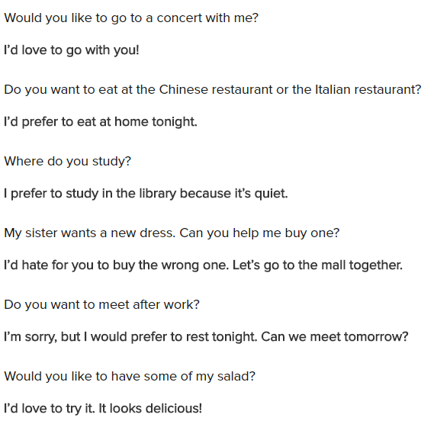

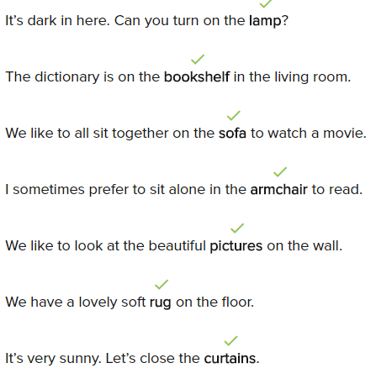

**Skill Practice**

Where did Mrs. Berry get the rug?

-> She bought the rug in India.

Where did Mrs. Berry get the curtains?

-> She found the curtains in China.

Where did Mrs. Berry get the lamp?

-> She got the lamp from her grandfather.

What is on the bookshelf?

-> Pictures of Mrs. Berry and her husband

Where would Khae prefer to sit?

-> In the armchair